Deep Learning Approaches for Image Captioning: A Review of CNN and Transformer Models
Ali Hamza
Registration Number: B23F0063AI106
Zarmeena Jawad
Registration Number: B23F0115AI125
Department of Artificial Intelligence
Pak-Austria Fachhochschule Institute of Applied Sciences and Technology
Course Title: Digital Image Processing
Course Code: COMP-342
Instructor: Mr. Hussan Ali Shah
Submission Date: 10 February 2026

Abstract
Image captioning is an important research problem in digital image processing that focuses on automatically generating meaningful and natural language descriptions for images. This task requires the integration of visual perception and linguistic understanding, making it a challenging problem at the intersection of computer vision and natural language processing. Traditional image captioning systems relied on handcrafted features and rule-based sentence generation, which limited their ability to generalize across diverse visual scenes. With the emergence of deep learning, particularly Convolutional Neural Networks (CNNs) and Transformer-based models, significant improvements have been achieved in caption accuracy, fluency, and semantic relevance.
Recent research has emphasized the use of CNNs for visual feature extraction and Transformers for sequence modeling due to their attention mechanisms and ability to capture long-range dependencies. This literature review analyzes recent research articles published between 2020 and 2024 that focus on CNN and Transformer-based image captioning approaches. The review summarizes the methods used, datasets, evaluation metrics, key results, and limitations, presents a comparative analysis, identifies research gaps, and discusses potential future directions for improving image captioning systems.
Table of Contents
Abstract i
Table of Figures iii
1. Introduction 1
2. Literature Review 2
3. Comparative Analysis Table 5
4. Gap Identification 5
5. Future Directions 6
References 7

Table of Figures
Figure 1BLIP: Bootstrapped Vision-Language Pretraining 2
Figure 2 BLIP-2: Efficient Vision-Language Pretraining 3

Introduction
Image captioning refers to the automatic generation of textual descriptions that accurately describe the content of an image. It is a fundamental task in digital image processing because it enables machines to understand visual information and express it in natural language. Image captioning combines techniques from computer vision, which focuses on visual feature extraction, and natural language processing, which focuses on sentence generation. The task has gained increasing attention due to its wide range of applications, including accessibility tools for visually impaired individuals, image retrieval systems, and intelligent multimedia applications.
Earlier image captioning approaches were based on handcrafted visual features and predefined language templates, which resulted in limited descriptive capabilities. With the development of deep learning, CNNs became widely used for extracting high-level semantic features from images. Initially, these features were combined with recurrent neural networks for caption generation. However, recurrent models faced limitations in modeling long-term dependencies. Transformer-based architectures addressed these issues by using self-attention mechanisms, enabling more accurate and context-aware captions. As a result, CNN–Transformer models have become the dominant approach in modern image captioning research.

Literature Review
Recent research in image captioning has increasingly focused on CNN and Transformer-based architectures due to their ability to jointly model visual and linguistic information. Li et al. (2022) proposed the BLIP framework, which introduces a bootstrapping strategy for vision–language pretraining using noisy web image–text pairs. The model employs a CNN-based visual encoder for extracting image features and a Transformer-based decoder for caption generation. BLIP was evaluated on the MS COCO dataset using BLEU and CIDEr metrics and achieved higher scores compared to earlier CNN–RNN-based models, indicating improved caption fluency and semantic relevance (Li et al., 2022). However, the authors noted that the approach requires large-scale pretraining data and significant computational resources, which limits its feasibility for smaller research environments.
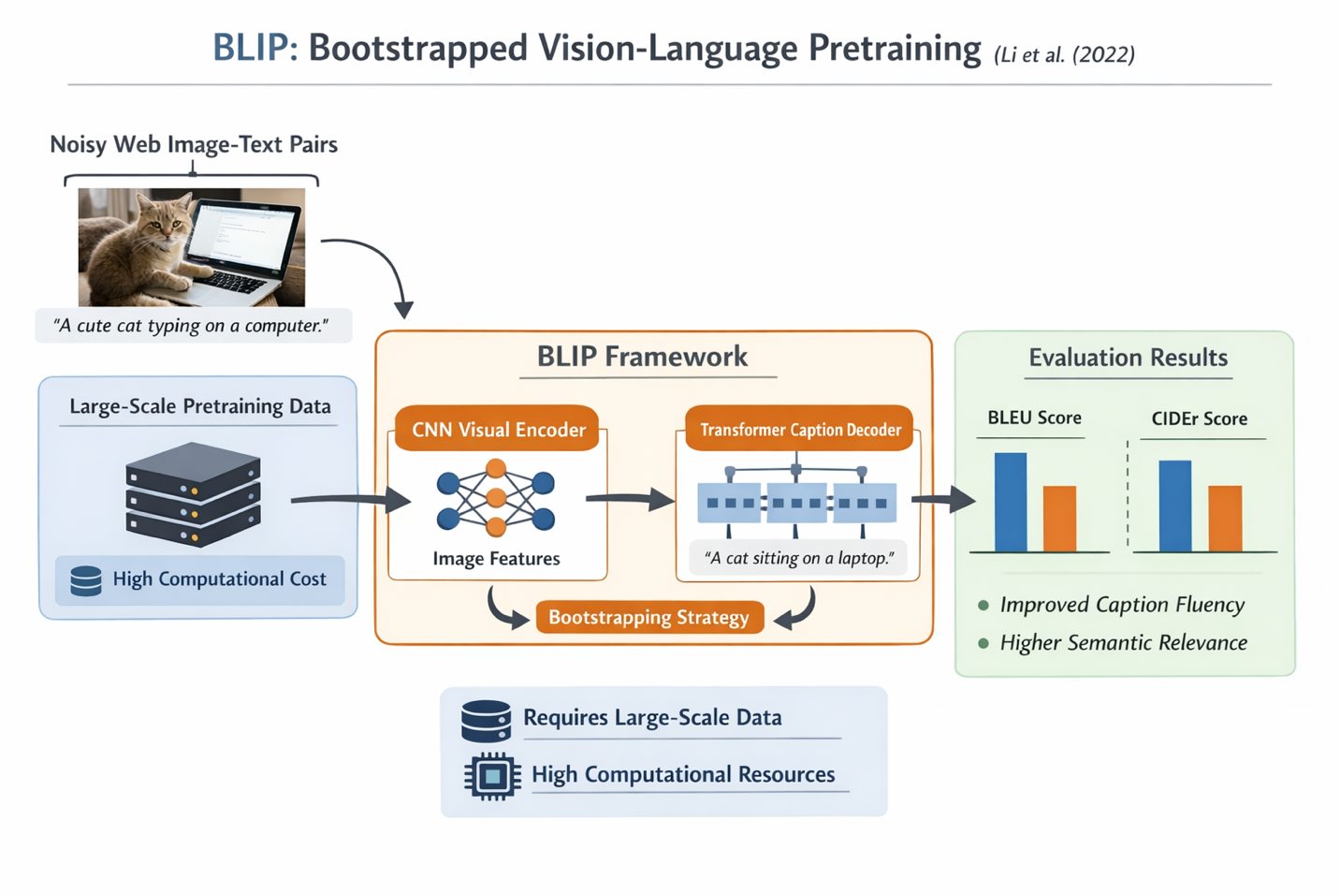
Figure 1BLIP: Bootstrapped Vision-Language Pretraining
Similarly, Wang et al. (2022) introduced the Generative Image-to-Text Transformer (GIT), a unified Transformer-based framework designed for image captioning and other vision–language generation tasks. The model uses CNN-extracted visual features as input to a Transformer decoder trained in an autoregressive manner. Experimental results on the MS COCO dataset demonstrated strong performance improvements in CIDEr and SPICE metrics, showing better alignment between visual content and generated captions compared to baseline models (Wang et al., 2022). Despite these gains, the study highlighted that the large model size and high training cost make deployment challenging in real-time and resource-constrained scenarios.
To address efficiency concerns, Li et al. (2023) proposed BLIP-2, which significantly reduces training cost by connecting frozen pretrained image encoders and large language models through a lightweight querying Transformer. The model was evaluated on MS COCO using CIDEr as the primary metric and achieved competitive performance while requiring far fewer trainable parameters than fully fine-tuned Transformer models (Li et al., 2023). Although BLIP-2 improves computational efficiency, its reliance on frozen pretrained components limits its adaptability to domain-specific image captioning tasks.
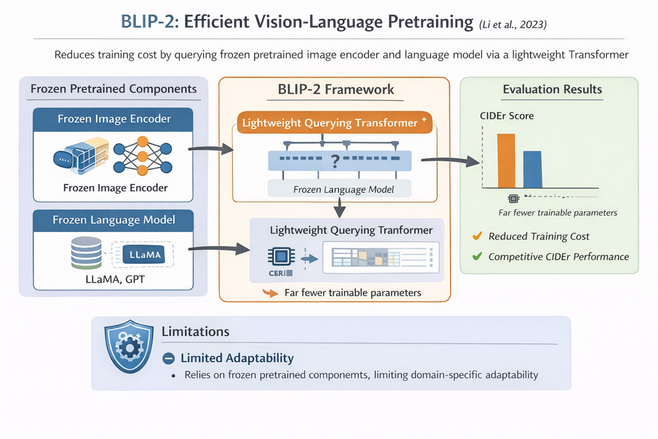
Figure 2 BLIP-2: Efficient Vision-Language Pretraining
Attention mechanisms have also been explored to improve caption quality in complex scenes. Chen et al. (2023) proposed a Transformer-based image captioning model with enhanced visual attention to better capture spatial relationships among objects. Using the MS COCO dataset and evaluation metrics such as BLEU, METEOR, and CIDEr, the model produced more semantically accurate and detailed captions compared to standard attention-based Transformers (Chen et al., 2023). However, the authors reported that the model struggled with rare objects and images containing unfamiliar visual concepts, indicating limitations in generalization.
Hybrid architectures combining CNNs and Vision Transformers have recently gained attention. Zhang et al. (2024) proposed a CNN–Vision Transformer hybrid model, where CNNs extract local visual features and Transformers model global contextual dependencies. Experiments conducted on the MS COCO and Flickr30k datasets showed improvements in caption diversity and sentence coherence, as measured by CIDEr and BLEU scores (Zhang et al., 2024). Despite these improvements, the increased architectural complexity led to longer training times and higher computational requirements, which may restrict its use in practical applications.
In an effort to balance performance and efficiency, Kumar et al. (2024) introduced a lightweight Transformer-based image captioning model optimized for reduced computational cost. The model was evaluated on the MS COCO dataset using BLEU and CIDEr metrics and achieved results comparable to larger models while significantly reducing training time (Kumar et al., 2024). However, qualitative analysis revealed that the generated captions were often less descriptive for complex scenes involving multiple objects and interactions.
Overall, the reviewed studies demonstrate that CNN and Transformer-based models have substantially advanced image captioning performance in recent years (Li et al., 2022; Wang et al., 2022; Li et al., 2023). Large-scale Transformer models achieve high accuracy and fluency but introduce challenges related to computational cost and data dependency, while lightweight and hybrid approaches trade descriptive richness for efficiency (Zhang et al., 2024; Kumar et al., 2024). These findings highlight the need for future research that balances efficiency, robustness, and caption quality.

Comparative Analysis Table
Paper | Year | Method | Dataset | Metrics | Results | Limitations
Li et al. (BLIP) | 2022 | CNN + Transformer | MS COCO | BLEU, CIDEr | High caption accuracy | High compute cost
Wang et al. (GIT) | 2022 | CNN + Transformer | MS COCO | CIDEr, SPICE | Strong generation | Large model size
Li et al. (BLIP-2) | 2023 | Transformer-based | MS COCO | CIDEr | Efficient training | Depends on pretrained models
Chen et al. | 2023 | Attention Transformer | MS COCO | BLEU, METEOR | Better semantics | Rare object issues
Zhang et al. | 2024 | CNN + ViT | COCO, Flickr30k | CIDEr, BLEU | Diverse captions | High training time
Kumar et al. | 2024 | Lightweight Transformer | MS COCO | BLEU, CIDEr | Efficient | Limited detail

Gap Identification
Despite significant advancements in CNN and Transformer-based image captioning, several limitations remain. Many state-of-the-art models rely on large-scale annotated datasets and extensive computational resources, making them difficult to deploy in resource-constrained environments. Additionally, models often struggle with rare objects, complex visual relationships, and images from unseen domains, reducing their robustness in real-world applications.
Another important gap lies in evaluation methodologies. Commonly used metrics such as BLEU and CIDEr primarily measure linguistic similarity and do not fully assess factual correctness or visual grounding. As a result, some models generate fluent but incorrect captions, a phenomenon known as caption hallucination. Addressing these gaps is essential for building reliable and trustworthy image captioning systems.

Future Directions
Future research should focus on developing lightweight and efficient Transformer-based image captioning models that maintain high performance while reducing computational requirements. Techniques such as parameter-efficient fine-tuning, self-supervised learning, and knowledge distillation can help address data and resource constraints. Incorporating external knowledge sources and improved attention mechanisms may further enhance caption accuracy and contextual understanding.
Another promising direction involves improving evaluation strategies by incorporating grounding-aware and factuality-based metrics. Models that explicitly align generated words with image regions can reduce hallucination and improve reliability. The chosen research idea can contribute by exploring a hybrid CNN–Transformer framework that balances efficiency, accuracy, and robustness, making image captioning systems more suitable for real-world deployment.

References
Albadarneh, I. A., Hammo, B. H., & Al-Kadi, O. S. (2025). Attention-based transformer models for image captioning across languages: An in-depth survey and evaluation. Computer Science Review, 58, 100766. https://doi.org/10.1016/j.cosrev.2025.100766
Assad, S., Isa, N. A. M., & Saleh, S. A. M. (2026). Hybrid CNN-Transformer Models for Industrial Defect Detection: A Systematic Review. Results in Engineering, 109457. https://doi.org/10.1016/j.rineng.2026.109457
Dosovitskiy, A., Beyer, L., Kolesnikov, A., Weissenborn, D., Zhai, X., Unterthiner, T., Dehghani, M., Minderer, M., Heigold, G., Gelly, S., Uszkoreit, J., & Houlsby, N. (2021). An Image is Worth 16x16 Words: Transformers for Image Recognition at Scale (arXiv:2010.11929). arXiv. https://doi.org/10.48550/arXiv.2010.11929
Li, J., Li, D., Xiong, C., & Hoi, S. (2022a). BLIP: Bootstrapping Language-Image Pre-training for Unified Vision-Language Understanding and Generation (arXiv:2201.12086). arXiv. https://doi.org/10.48550/arXiv.2201.12086
Li, J., Li, D., Xiong, C., & Hoi, S. (2022b). BLIP: Bootstrapping Language-Image Pre-training for Unified Vision-Language Understanding and Generation. Proceedings of the 39th International Conference on Machine Learning, 12888–12900. https://proceedings.mlr.press/v162/li22n.html
Mokady, R., Hertz, A., & Bermano, A. H. (2021). ClipCap: CLIP Prefix for Image Captioning (arXiv:2111.09734). arXiv. https://doi.org/10.48550/arXiv.2111.09734
Radford, A., Kim, J. W., Hallacy, C., Ramesh, A., Goh, G., Agarwal, S., Sastry, G., Askell, A., Mishkin, P., Clark, J., Krueger, G., & Sutskever, I. (2021). Learning Transferable Visual Models From Natural Language Supervision. Proceedings of the 38th International Conference on Machine Learning, 8748–8763. https://proceedings.mlr.press/v139/radford21a.html
Sharma, D., Dingliwal, R., Dhiman, C., & Kumar, D. (2022). Lightweight Transformer with GRU Integrated Decoder for Image Captioning (p. 438). https://doi.org/10.1109/SITIS57111.2022.00072
Vinyals, O., Toshev, A., Bengio, S., & Erhan, D. (2015). Show and Tell: A Neural Image Caption Generator (arXiv:1411.4555). arXiv. https://doi.org/10.48550/arXiv.1411.4555
Wang, J., Yang, Z., Hu, X., Li, L., Lin, K., Gan, Z., Liu, Z., Liu, C., & Wang, L. (n.d.). GIT: A Generative Image-to-text Transformer for Vision and Language.

